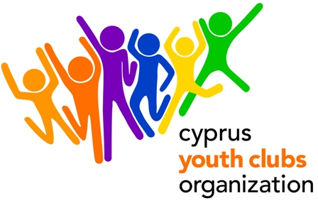
ENGAGE CHANGE - PROJECT OUTLINE

Youth in Action, sub-Action 3.1 Cooperation with the Neighbouring Partner Countries of the European Union
- Project title: ENGAGE CHANGE
- Organization: Cyprus Youth Clubs Organization (CYCO)
- Main theme for the project: promoting exchanges, cooperation and training in the field of youth work.
- We encourage organizations to participate with 2 people each. We have already formed the partnership (for a 4.3 Training Course with the same title) but we are now looking for TWO partners from any of the Neighbouring Partner Countries in order to apply for the same Training Course but under 3.1.
- Project type: Youth in Action, 3.1 Cooperation with the Neighbouring Partner Countries of the European Union
- Organizations’ Country: Cyprus
- The project starts: 1 March 2011 (arrival date)
- The project ends: 7 March 2011 (half day activities/ half day departures)
- Deadline for applications: July 26
- Duration: 7 days with the travelling days
- Group age (average): none
- Contact person: Dalosi Anna
- E-mail: adalosi@cyco.org.cy
- Tel.: +35722323260
- Fax: +35722321979
- Summary of the project: Young people and Youth workers will exchange ways to empower youth in rural areas to participate in their organizations and their communities. Enhancement of young people’s skills and attributes is seen as a major way in developing the capacity of youth organizations in rural areas. We will develop methods to engage young people in Youth Organizations and to enforce them to lead change. Ways to promote young people’s active citizenship will be explored. Intercultural learning will take place at all stages of the activity. Participants will share their experiences, present successful methods and form new tools for addressing the project’s objectives.
- Financial aspects: participants will be reimbursed for the 70% of the travel cost on display of their boarding passes. Food and accommodation is paid. Participants will be required to pay a participation fee of €30.
- Safety & Insurance: We will require copies of the travel insurances before travelling to Cyprus.
- How to participate: Send us a short description of your organization and the link to you website (if available). After you fill in the Part 3 (make sure it is the 2010 version http://ec.europa.eu/youth/youth-in-action-programme/doc411_en.htm ), fax it to +357 22321979 or send the scanned version to Anna Dalosi adalosi@cyco.org.cy and mail the original to:
ANNA DALOSI, CYPRUS YOUTH CLUBS ORGANIZATION
Platia Iroon 1, Ag. Mamas, Lakatamia, 2330, CUPRUS

Neighbouring Partner Countries:

Albania
Bosnia and Herzegovina
Croatia
Former Yugoslav Republic of Macedonia (FYROM)
Kosovo, under UNSC
Resolution 1244/1999
Montenegro
Serbia
Armenia
Azerbaijan
Belarus
Georgia
Moldova
Russian Federation
Ukraine
Algeria
Egypt
Israel
Jordan
Lebanon
Morocco
Palestinian Authority of the
West Bank and Gaza Strip
Syria
Tunisia

